**Project Design Phase -1**

**Solution Architecture**

|  |  |
| --- | --- |
| Date | 03 October 2022 |
| Team ID | PNT2022TMID40244 |
| Project Name | Web Phishing Detection |
| Maximum Marks | 2 Marks |

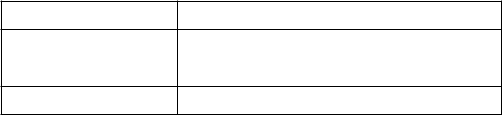

**Architecture:**

